Bibliography (Con’t.)  McGowan, J., Hogg, W., Campbell, C., & Rowan, M. (2008). Just-in-time information improved decision-making in primary care: A randomized controlled trial. Plos ONE, 3(11), 1-6. doi:10.1371/journal.pone.0003785  Newall, E., Gratton, C., & Maltby, J. (2014). 'Today and more than ever, I feel like a researcher': Successful online learning collaborations between librarians and a graduate school. Health Information & Libraries Journal, 31(2), 167-171. doi:10.1111/hir.12061  Whitehair, K. J. (2010). Reaching Part-Time Distance Students in Diverse Environments. Journal of Library & Information Services in Distance Learning, 4(3), 96-105. doi:10.1080/1533290X.2010.503166  Wilmes, N. A. (2011). Providing Mobile Librarian Service to a College of Nursing to Increase Interactions and Transactions: One Wayne State University, Science and Technology Librarian's Experience. Science & Technology Libraries, 30(1), 99-107. doi:10.1080/0194262X.2011.545673  Contact Us  - Christopher W. Blackwell, Associate Professor, UCF College of Nursing  christopher.blackwell@ucf.edu  Andrew Todd, Nursing Subject Librarian, UCF Libraries andrew.todd@ucf.edu  Josie Weiss, Ph.D., Associate Professor, UCF College of Nursing  josie.weiss@ucf.edu  Angela Ritten, Clinical Assistant Professor, UCF College of Nursing angela.ritten@ucf.edu |  |  | Utilizing Library Resources to Improve the Quality of NP Education  University of Central Florida  - Christopher W. Blackwell, Ph.D., ARNP, ANP-BC, AGACNP-BC, CNE  Andrew Todd, MLIS, BSN, RN  Josie Weiss, Ph.D., ARNP, FNP-BC, PNP-BC, FAANP  Angela Ritten, DNP, ARNP, FNP-BC
7
How Can Librarians Help in Your Classes?  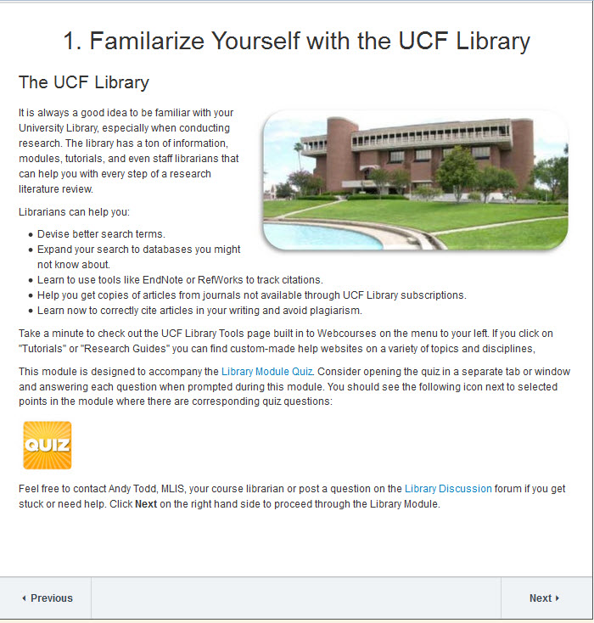  1) Integrated Library Modules |  |  | Selected Bibliography  Dorner, J. L., Taylor, S. E., & Hodson-Carlton, K. (2001). Faculty-librarian collaboration for nursing information literacy: A tiered approach. Reference Services Review, 29(2), 132-140.  Edwards, M. E., & Black, E. W. (2012). Contemporary instructor-librarian collaboration: A case study of an online embedded librarian implementation. Journal of Library & Information Services in Distance Learning, 6(3-4), 284-311.  Edwards, M., Kumar, S., & Ochoa, M. (2010). Assessing the value of embedded librarians in an online graduate educational technology course. Public Services Quarterly, 6(2/3), 271-291.  Guillot, L., & Stahr, B. (2004). A tale of two campuses: Providing virtual reference to distance nursing students. Journal of Library Administration, 41(1/2), 139-152. doi:10.1300/J111v41n01_11  Guillot, L., Stahr, B., & Meeker, B. (2010). Nursing faculty collaborate with embedded librarians to serve online graduate students in a consortium setting. Journal of Library & Information Services in Distance Learning, 4(1/2), 53-62. doi:10.1080/15332901003666951  Jacobs, S., Rosenfeld, P., & Haber, J. (2003). Information literacy as the foundation for evidence-based practice in graduate nursing education: A curriculum-integrated approach. Journal of Professional Nursing, 19(5), 320-328.  Kumar, S., Wu, L., & Reynolds, R. (2014). Embedded librarian within an online health informatics graduate research course: A case study. Medical Reference Services Quarterly, 33(1), 51-59.  Lin, W., Betts, V. T., Jacob, S., Nollan, R., & Norris, T. (2013). Making meaningful connections: Evaluating an embedded librarian pilot project to improve nursing scholarly writing. Journal of the Medical Library Association, 101(4), 323-326.
 | 1 |  | 6

5) Course Specific Library Liaisons  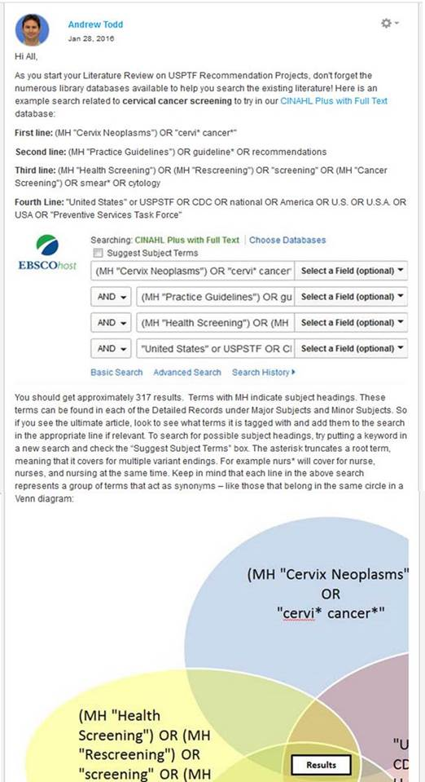 |  |  | 2) Librarian-facilitated discussion boards  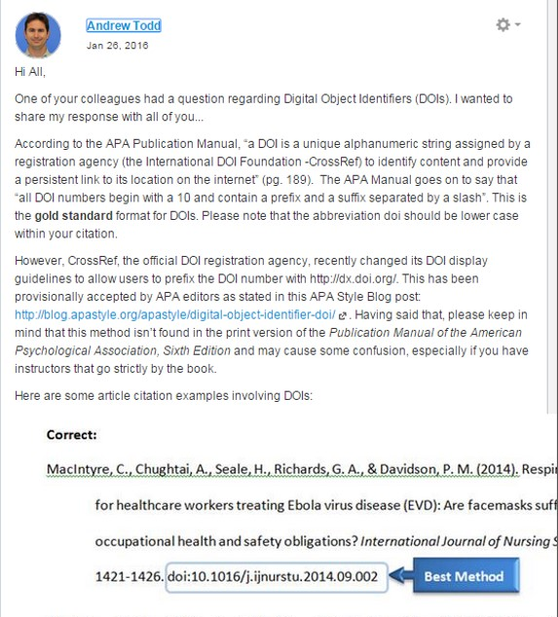  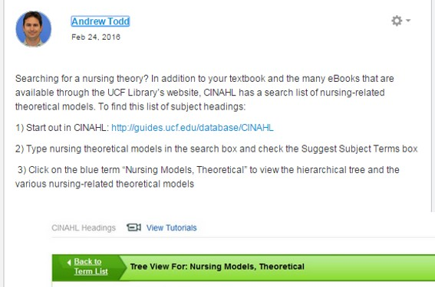
5 |  |  | 2

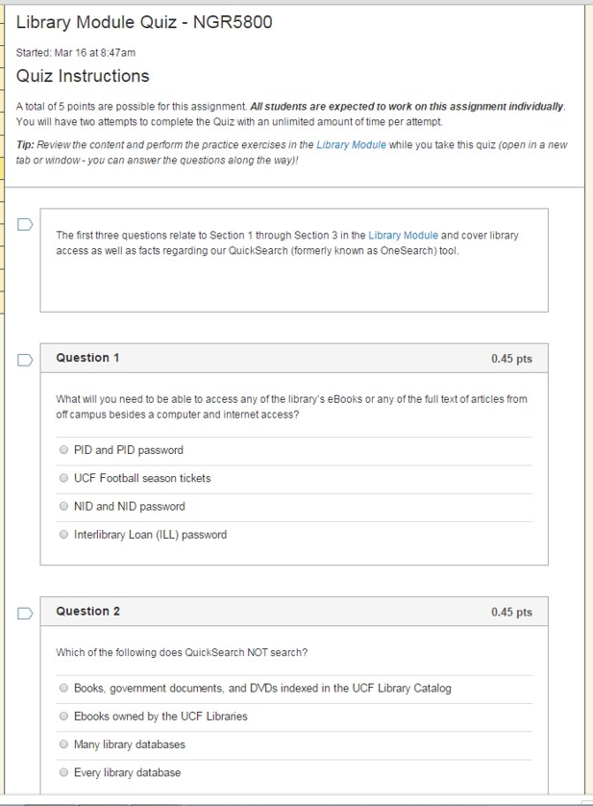  3) Course Specific Library Quizzes |  |  | 4) Posting proxy-enabled links/resources  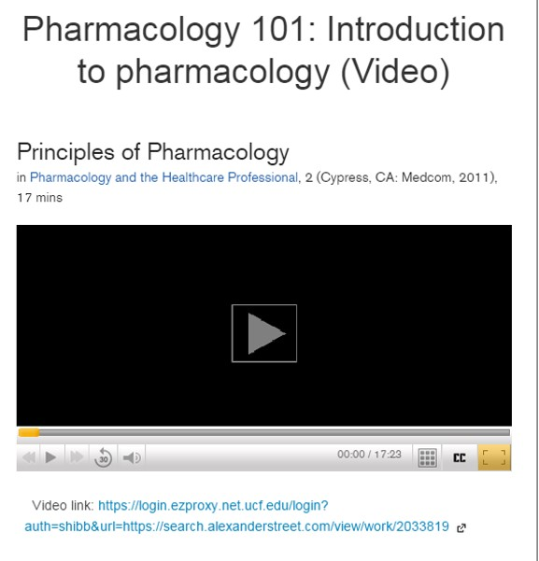  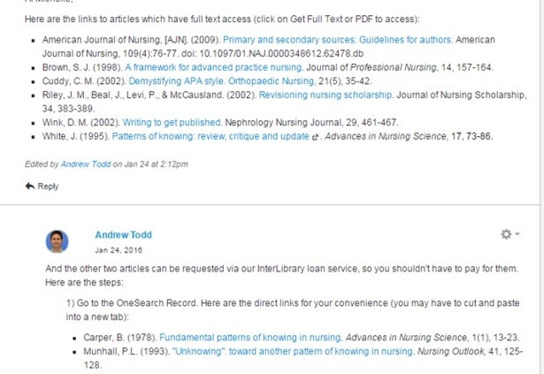
3 |  |  | 4

